**TRAINING REPORT ON**

**AGRICULTURAL VALUE CHAIN DEVELOPMENT AND MARKET LINKAGES**

**DATE: 16th – 27th MAY 2022**

**PLACE: WEST MERIDIAN HOTEL, NAIROBI, KENYA**

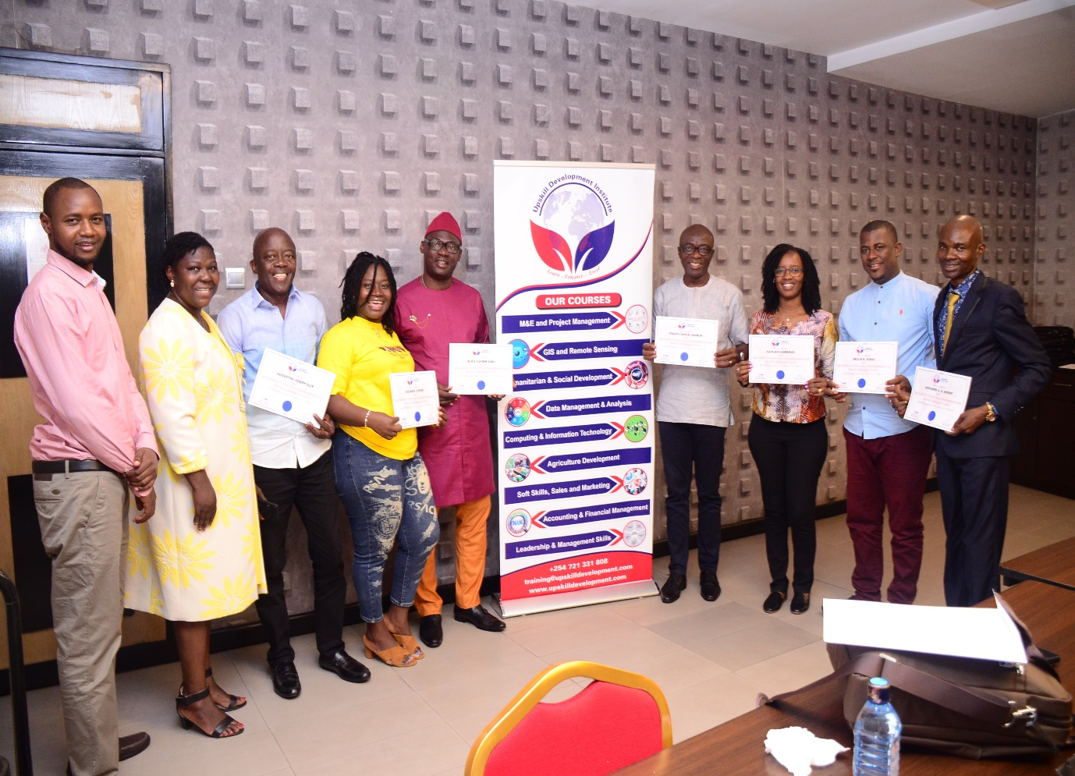

**Preamble:**

This training report was developed by the SMEDA team of participants for the Agricultural Value Chain Development and Market Linkages Training, through the Up-skill Development Institute in Kenya.

The contents of this report are the sole responsibility of the participants, and does not necessarily reflect the views of the trainer or SMEDA.



Table of Contents

1. BACKGROUND: 3

2. TRAINING OBJECTIVES: 5

3. METHODOLOGY: 6

4. TRAINING INSTITUTION PROFILE: 6

5. RESOURCE PERSONS’ PROFILE: 7

6. PARTICIPANTS’ PROFILE: 10

7. VENUE AND DATES: 10

8. TRAINING SESSIONS: 10

DAY 1: OPENING SESSION: INTRODUCTION OF PARTICIPANTS AND RESOURCE PERSONS AND INTRODUCTION TO THE COURSE 10

MODULE I: INTRODUCING THE VALUE CHAIN: 11

DAY 2: MODULE II: VALUE CHAIN MAPPING AND ANALYSIS: 12

DAY 3: MODULE III: ANALYZING MARKET AND MARKET DEVELOPMENT: 15

DAY 4: MODULE VI: ECONOMIC SUSTAINABILITY: 16

DAY 5: MODULE V: VALUE CHAIN RELATIONS AND GOVERNANCE: 17

DAY 6: MODULE IV: BUSINESS SERVICE AND FINANCE: 19

DAY 7: MODULE IIV: CHAIN CONTEXT: MACRO-ENVIRONMENT: 20

DAY 8: MODULE VIII: DEVELOPING STRATEGIES FOR CHAIN EMPOWERMENT AND BUILDING ENGAGEMENT AND CHAIN DEVELOPMENT: 21

DAY 9: MODULE XI: CHAIN MONITORING AND EVALUATION: 24

DAY 10: MODULE 10: CHAIN LEARNING AND INNOVATION, COMPETENCIES AND ROLES OF CHAIN DEVELOPMENT FACILITATOR’S AND SUPPORT AGENCIES: 27

10. PRE AND POST TRAINING ASSESSMENT: 29

11. LESSONS LEARNT AND BEST PRACTICES: 29

12. CONCLUSION: 30

13. RECOMMENDATIONS: 31

14. ANNEXES I: TRAINNG PROGRAMME 33

15. ANNEXES II: PARTICIPANTS LIST 37

16. ANNEXES II: CERTIFICATION PHOTOS 38

# **BACKGROUND:**

Agriculture, including agribusiness, is a key sector of the Sierra Leone economy, contributing more than half of the GDP and accounting for the largest share of labour markets, both by type of employment and sector contribution. The sector is dominated by smallholder production of staple crops, mainly rice and cassava, which together account for about three‐quarter of the volume of agricultural production.

However, agro‐processing SMEs in Sierra Leone generally lack access to stable, viable markets for their products**.** The entire agribusiness sector, including agro‐processing, is highly fragmented, consisting of few medium‐ and large‐size formal firms, and a vast number of small, low‐productivity firms operating in few commodities, such as oil palm, rice, coffee, and cocoa. The market for business development services (BDS), entrepreneurial training, and agribusiness‐focused content is fragmented. Business development service providers have basic business training materials, but they lack proper information and experience in agribusiness and the food sector, and programmatic offerings typically do not extend beyond basic business plans and start‐up advice. Hence, agricultural productivity remains low, combined with low levels of farmer organization and coordination, which lead to highly unstable markets for agricultural commodities and unpredictability for inputs to agro‐processing SMEs

In this regard, the Small and Medium Enterprises Development Agency has a critical role to play in developing efficient tools and methods for supporting the agro-processing SMEs. However, recent Capacity Needs Assessment undertaken by SMEDA in 2021 indicated that SMEDAs staff, although experienced from many other previous positions in various other organizations and private sector-lacks specialized and SME specific-knowledge. In order for SMEDA to be at the fore-front of the SME development activities including sustainable agro-processing practices several key trainings and capacity building activity needs have been identified:

* Significant trainings and improvements in the SME-specific know-how and best practices (including study visits to the similar SME contexts, and
* Trainings, such as Value Chain Development, Agro-business development, food technology, Packaging and others).

Against this backdrop, it was important that SMEDA technical staff commence training activity in order to transform and positioned the organization very well. To achieve these objectives, specific apro-processing related trainings were identified for key personnel of SMEDA who have the highest potential of creating spill-over effects and sharing the knowledge gained with their colleagues.

In order to commence the transformation in the Project management and preparation of SMEDA to contribute to the SME agro-business development focused in-person trainings should be commenced in QI of 2022. This will enable SMEDA to achieve two objectives:

1. Improve the quality of support to the one of largest SME segments in the country agro-business, and
2. Introduce in Sierra Leone know-how of latest proven technologies and solutions that have been tested in other countries across Africa.

In order to achieve this objective, the Chief Executive Officer (CEO) and **6 other technical staff** of SMEDA have been trained and gained increased knowledge in Agricultural Value Chain Development and Market Linkages, as master trainers for both SMEs and Policy Advisors.

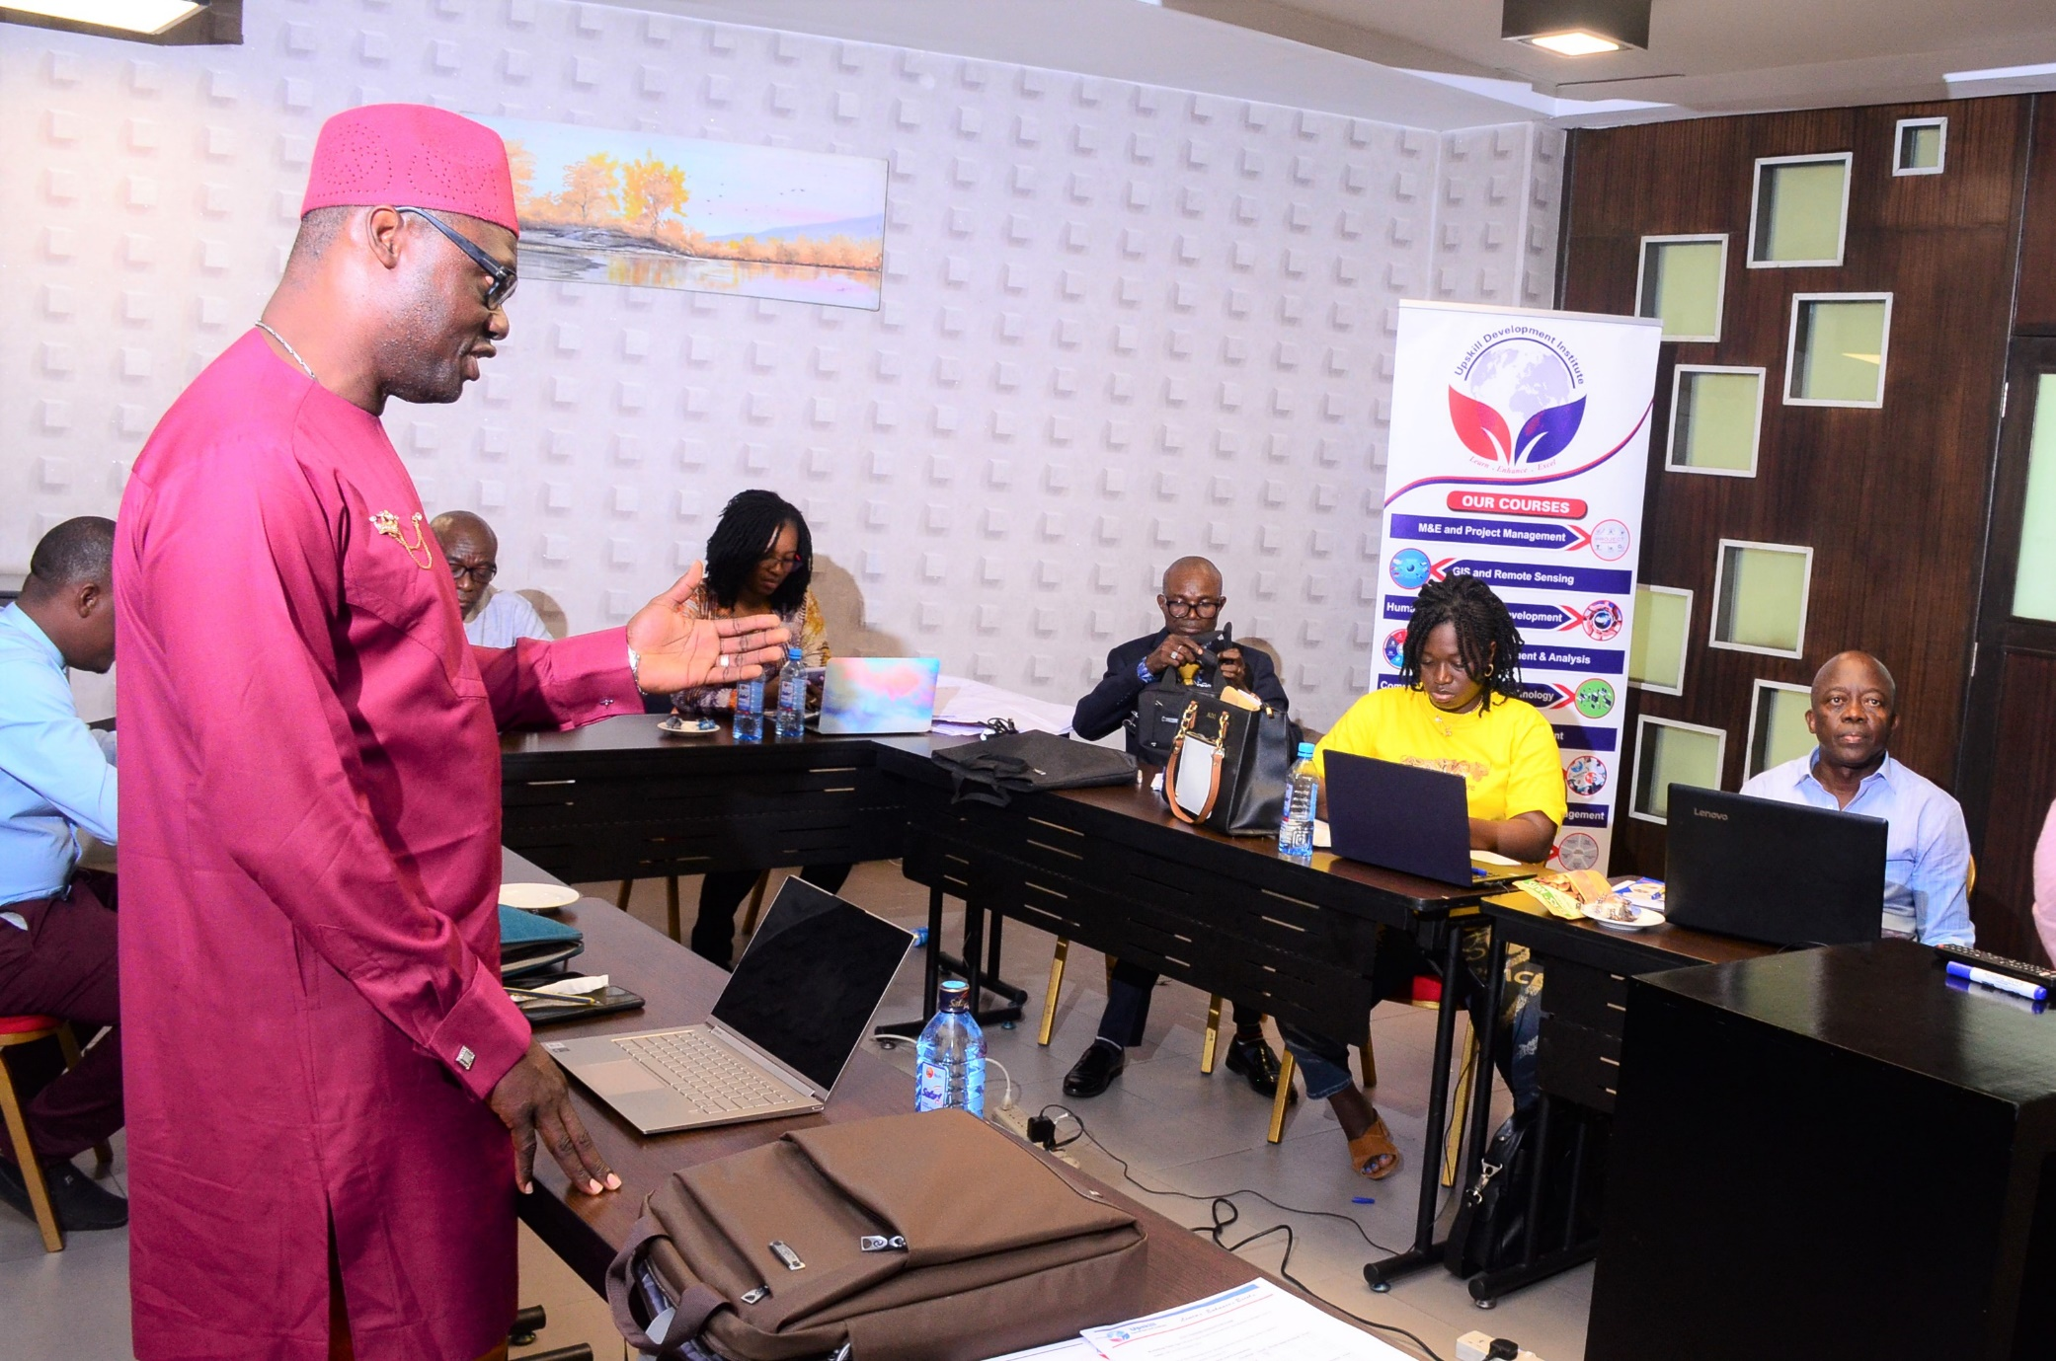

# **TRAINING OBJECTIVES:**

The objective of the training was as follows:

* To help the Small and Medium Enterprises Development Agency obtain specialized knowledge and experience in SME Agro-business development and support programs;
* To understand specific know-how in products used in SME Agro-business development, through getting to know the results achieved and learning from the other countries’ experience;
* To enhanced participants on the opportunity to understand the processes leading to SME success in the Agro-business sectors in other country (methods, instruments, procedures, potential impediments, etc.) and;
* To have first-hand experience of the results achieved and benefits gained for Sierra Leone context.

The overall objective was to strengthen the capacity of SMEDA in SME-Specific field and build a solid technical team that will aid and facilitate the required technical advice and expertise amongst relevant MDAs in Sierra Leone in developing the SME sector.

# **METHODOLOGY:**

The training aimed at building the capacity and technical competences of the SMEDA staff on Agricultural Value Chains and Market Development. In achieving this, the training adapted the combination of a classroom lectures, slides presentations and experience sharing style of teaching. Questions and answers also formed a critical way of delivery methods.

# **TRAINING INSTITUTION PROFILE:**

Up-skill Development Institute is a training research and consultancy services provider to international organizations. The institution assists clients to improve their skills and confident by offering the best possible solutions to enable them fulfil their objectives for a sustainable result. Up-skill Development Institute strive to improve the quality and accessibility of the training by creating an environment that ensures successful learning from start to finish. Choosing an institution that support your needs and understands your goals can be a challenge. The institution aims to eliminate this overwhelming process by providing its clients with high-quality solutions and courses that fully encompass the shifting tides of the different field.

# **RESOURCE PERSONS’ PROFILE:**

Given below is a brief description of the trainers/resource persons who delivered the sessions from the 16th – 27th May, 2022.

|  |  |  |  |  |
| --- | --- | --- | --- | --- |
| **No.** | **Name** | **Designation** | **Qualifications** | **Modules Covered** |
| 1 | Samuel Ngunjiri | Lecturer, Egerton University: Agri-business Management and Economic | PhD - Agricultural Economics (About to finish) | Module I: Introducing the Value Chain |
|  |  |  |
| Short Courses Trainer (Agriculture Development) - Upskill Development Institute | Collaborative Masters in Agricultural and Applied Economics (CMAAE) | Module 2: Value Chain Mapping and Analysis |
|  |  |  |
|  | BSc – Agribusiness Management | Module 3: Analysing Market and Market Development |
|  |  |  |
|  |  | Module 4: Economic Sustainable |
|  |  |  |
|  |  | Module 5: Value Chain Relations and Governance |
|  | | | | |
| 2 | Benjamin Wamalwa Kisiangani | Research Consultant for JKUAT Ranger Project- Value Addition Across Key Value Chains in the ASAL Areas | Master of Science in Agricultural Economics (Egerton university, Nakuru (Kenya) | Module 6: Business Development Service and Finance |
|  |  |  |
| Short Courses Trainer Upskill Development Institute in Agriculture | BSc. Agricultural Economics | Module 7: Chain Context: Macro-Environment |
|  |  |  |
| Part-time Lecturer- Laikipia University | Egerton University, Nakuru (Kenya), |  |
|  |  |  |
| Research Consultant for KALRO – KCSAP Project- Uptake for Improved Cook Stove (ICS) |  |  |
|  |  |  |
| Lead Researcher and Agri-Business Expert at Sustainable Community Development Services (SCODE) on the adoption of e-Cook Direct Solar Electric Pressure Cooker in Nakuru and Baringo Counties |  |  |
|  |  |  |  |  |
| 3 | Dr. Annah Indeche | Lecturer, Department of Horticulture and Food Security- JKUAT | PhD in Agriculture - OKAYAMA UNIVERSITY, JAPAN | Module 8: Developing Strategies for Chain Empowerment and Building Engagement and Chain Development |
|  |  |  |
| 2020 – Present Short Courses Trainer (Agriculture Development) - Upskill Development Institute | MPhil in Agricultural Extension - UNIVERSITY OF CAPE COAST, GHANA | Module 9: Chain Monitoring and Evaluation |
|  |  |  |
| Senior Field Technologist, Department of Horticulture, JKUAT | MSc in Development Studies - JKUAT, KENYA | Module 10: Chain Learning and Innovation, Competencies and Roles of Chain Development Facilitators and Support Agencies |
|  |  |  |
| Technical staff, Department of Horticulture, JKUAT Kenya | BSc in Horticulture - JKUAT, KENYA |  |
|  |  |  |
|  | Short course - Diploma in Vegetable Production and Research - WORLD VEGETABLE CENTRE, ARUSHA, TANZANIA |  |
|  |  |  |
|  | Short course- Certificate in Organic Farming - KIOF, KENYA |  |
|  |  |  |  |  |

(See Annex iii for detailed agenda)

# C:\Users\SMEDA Ent Dev\Desktop\Training Repoort\Photos 2\IMG-20220530-WA0038.jpg**PARTICIPANTS’ PROFILE:**

The training participants included technical staff members of SMEDA directly involved in the designing, implementing and reporting of key programme activities. Total number of participants was 7 (5 males and 2 females) (see Annex i. for list of participants)

# **VENUE AND DATES:**

The training was organized at the Meridian Hotel, Nairobi Kenya, from the 16th – 27th May 2022.

# **TRAINING SESSIONS:**

## **DAY 1: OPENING SESSION: INTRODUCTION OF PARTICIPANTS AND RESOURCE PERSONS AND INTRODUCTION TO THE COURSE**

The training began with an introduction of participants, resource persons and the team of Up-skill Development Institute. Speaking on behalf of the Up-skill Development Institute, Training Coordinator, and Daniel Ndiritu Ndung’u warmly welcomed the participants to the city of Nairobi, Kenya. He also thanked SMEDA for choosing Up-skill Development Institute and the World Bank through the Sierra Leone Agro-processing Competitiveness Project for supporting the training. The training coordinator, Daniel Ndiritu Ndung’u noted that the sessions will last for two weeks and it covered 10 modules including field trips and site visit for experience sharing. He however, encourages all the participants to sparing time to attend these sessions.

Speaking on behalf of SMEDA, Chief Executive Officer (CEO), Sharka Samuel Sannoh, registered appreciation to Up-skill Development Institute for accepting the offer of SMEDA to undertake a two weeks training course with them. The selection he said was done based on competitive advantage and that Up-skill Development Institute he underscored has the pedigree to efficiently and effectively deliver the course contents as expected. Mr. Sannoh further thanked Mr. Ndiritu Ndung’u training coordinator Up-skill Development Institute for properly coordinating the entire process. He also expressed special thanks to Ambassador and staff of the Sierra Leone Embassy and particularly Mr. Abdul Kargbo, Ambassador Plenipotentiary for their warned welcomed to the city of Nairobi. He concluded by extending special thanks and appreciation to the Government of Sierra Leone, the World Bank and the Project Coordinating Unit of the Sierra Leone Agro-processing Competitiveness Project for the opportunity given to SMEDA as a way of institutional capacity building.

## **MODULE I: INTRODUCING THE VALUE CHAIN:**

In this session participants were introduced to the core concepts of Value Chain Development. The discussion revolved around the following key topics: definition of a value chain, traditional selling systems compared with a value chain marketing system, value chain marketing systems, value chain framework, the “new” framework for chain empowerment and chain empowerment.

**The session also discussed the following sub-topics:**

* **Vertical axes,** different stages of the chain establish links with one another (e.g., input suppliers and producers).
* **The horizontal axes, w**hen relationships are established at the same level (e.g., producers who form a cooperative to reduce certain costs).
* **Governance of the VC, r**elationships which may evolve between those who are in a position to set the conditions of the transactions at various stages of the VC or even for all of it and the other stakeholders
* **Competitiveness, t**he capacity to provide and sell, on a sustainable basis, one or more marketable goods or services on a given market under conditions of competition.

The session further elaborated on the following, Importance of a value chain development approach, traditional selling systems compared with value chain marketing systems (**Market “Push”** based on independent transactions between each node), **farmers isolated** from the consumer’s demands and preferences, **R & D** that function at a node level and **farmers** tend to receive minimal profit.

**Characteristics of a Value Chain,** Value Chain Framework **and Chain empowerment which can be achieved in two dimensions:**

* Increasing their **control over chain activities,** input procurement, sorting and grading, warehousing, processing, transport, trading, retailing, etc.
* Increasing their **control over management processes in the chain** (chain governance), grades and standards, market intelligence, quality assurance, innovation, information management, cooperation liaisons, finance, etc.

**Strategies for Chain Empowerment**

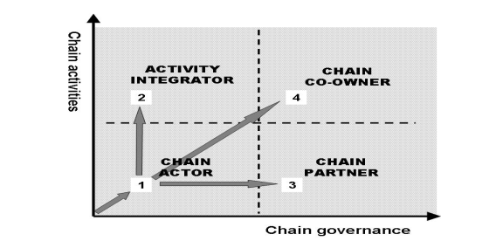Practical work, discussions, questions and answers also formed part of the session.

## **DAY 2: MODULE II: VALUE CHAIN MAPPING AND ANALYSIS:**

Module 2 session on Value Chain Mapping & Analysis started at around 9am with a reflection on Module 1: Introduction to Value Chain. The facilitator, Mr. Samuel Wamuyu proceeded to introducing the module, its objectives and key topics to be covered. Key topics within this module includes: definition of the concepts, steps in value chain development from chain selection, chain mapping and analysis, building engagement among actors, value-chain upgrading, chain monitoring and evaluation, to learning and innovation.

The session proceeded with an in-depth analysis of the VC Selection, Mapping and Analysis; discussing selection steps, developing criteria and sub-criteria for evaluation (including competitiveness and impact potential), ranking and selection of VC for promotion (including examples). The session further analyzed the value chains, products, VC actors, and VC supporter/support service providers. Also analyzed was how to determine which dimensions of the VC to map, example maps, the importance of making a VC map, and steps to undertake mapping including:

* Mapping the core processes in the VC;
* Identify and mapping the main actors;
* Mapping flows of products;
* Mapping knowledge and flows of information;
* Mapping the volume of products, number of actors and jobs;
* Mapping geographical flow of the products or services;
* Mapping the value at different levels of the VC;
* Mapping relationship and linkages between VC actors;
* Mapping services that feed into the VC;
* 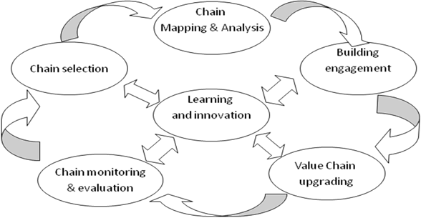Mapping constraints and potential solutions.

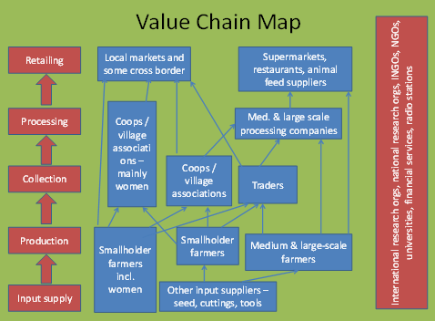A critical factor of note in this module were the practical activities accompanying the theoretical discussions. The tutor excellently facilitated a Moot exercise on mapping a VC, utilizing actual tools and processes. This serves as the highlight of the training as participants were introduced to different data collection and geo-mapping tools and software. Using a case study, participants were able to map VC actors in different locations in Sierra Leone utilizing geo-locators and different administrative levels of the map of Sierra Leone. This module and its exercises will be extremely helpful in guiding the practical implementation of a VC mapping during the course of our work.

## **DAY 3: MODULE III: ANALYZING MARKET AND MARKET DEVELOPMENT:**

In this session an overview of Analyzing Market and Market Development within the framework of value chain and details of why it is important and how it is carried out were discussed. In this context, participants were oriented on the process of data collection and the major steps involved in this process. Moreover, this session also revealed constraints and challenges within the value chain that has the propensity to disrupt the smooth operation of the value chain.

End market analysis

Vet finding/ develop action plan

Mapping Actors,

Function and relationship

Analyse data

Collect data

|  |  |  |  |
| --- | --- | --- | --- |
| **GEORGRAPHICAL MAPPING OF CASSAVA VALUE CHAIN**  **ACTORS IN SIERRA LEONE** | | | |
| **LOCATION** | **FARMERS** | **TRANSPORTERS** | **COLLECTOR** |
| Bo | 5 | 8 | 9 |
| Port Loko | 2 | 3 | 4 |
| Koinadugu | 6 | 2 | 3 |
| Pujehun | 7 | 3 | 7 |
| Bombali | 3 | 6 | 5 |
| **Total** | 23 | 22 | 28 |

## **DAY 4: MODULE VI: ECONOMIC SUSTAINABILITY:**

In the analysis, the training focusses on the economic dimension which says that a value chain is sustainable when the activities carried out by each stakeholder are commercially viable or fiscally viable for public services.

It was revealed that a value chain or a journey a commodity takes from production to consumer, involves a variety of activities performed by different players/ operators with the aim of delivery a valuable product to the market and eventually to the consumer

Each link in the chain can pose a potential loss in value or serves as an opportunity to ensure sustainable development for the people and natural environment involved.

It was further observed and understood that value chain can help in decision making by appropriate indicators, setting up base line surveys or informing on the changing situation of the actors related to the intervention.

However, in the assessment of chain performance in terms of economic efficiency the following issues were thoroughly and explicitly discussed.

* *Determining the value added along the stages of the value chain,*
* *The cost of production*
* *****The income of operators.*

In concluding, the presentation hinges on the fact that economic analysis of value chains often have to be based on cost estimates (actual costs and transaction costs).

The economic performance of a value chain can be benchmarked by comparing the value of important parameters with those of competing chains in other countries or similar.

## **DAY 5: MODULE V: VALUE CHAIN RELATIONS AND GOVERNANCE:**

This session started off with previous day’s recap, participants were asked to share their experiences on the previous module and topics. The modules covered 4 topics which includes:

* Analyzing value chain relations and governance
* Intro-importance of VC relations and governance
* Analysis of VC relations and governance and
* Group work, presentation

The session was one of the most interactive and discussion-oriented sessions during the training and it began with a brief overview of Value Chain Governance and Relationship, which was referred to as the relationships among the buyers, sellers, service providers and regulatory institutions that operate within or influence the range of activities required to bring a product or service from inception to its end use.

During the session, the following sub-topics were also covered:

1. Organization of value chain actors (e.g.) farmers, inputs suppliers, wholesalers and retailers etc: Protection of actor from competitive pressures that could worsen their terms of trade.
2. Relationship in the value chain: Building block between preferred business partners or actors.
3. Key to successful relationship within a value chain: Successful value chains are built on relationship strength of the actors based on:

* Shared vision;
* Culture
* Leadership;
* Compatible structure and processes;
* Mutual alignment of ability, resources and motivation;
* Commitment to continuous improvement, through innovation in products, processes and systems.
* Common interest helps actors to become owners of the (raw, semi-processed or finished) product at one stage in the VC.

1. Value chain actors and use of other tools of analysis, value chain relationship strength and potential are evaluated and characterized against three indicators:

* Strategic alignment
* Trust; Cooperation and Commitment;
* Power, dependence, opportunities and conflict and its resolution.

1. Chain Governance:

* Definition: The system of ensuring compliance with all and regulatory requirements that influence business operation and market access in a value chain.
* Instruments of governance include:
* contracts between value chain actors,
* government regulatory frameworks
* unwritten norms that determine who can participate in a market.
* Types of governance:
* Legislative governance: Externally determined basic rules that set conditions for participation in the chain;
* Judicial governance: Externally determined activities to audit performance and to check compliance with the rules - international standards regarding permissible levels of pesticide residues on imported products;
* Executive governance: Internally determined partnership regulations assist value chain actors in meeting operating rules – imposition by wholesalers that agricultural products be correctly harvested to prevent damage and degradation;
* Analyzing chain governance: Can be approached by separating three dimensions:
* Coordination Structures
* Rules and Regulations
* Control Mechanisms (Transmission of Information and Services).

At the end of the session, participants were asked to give their opinions as to why address chain governance?

* Respond to dynamic markets, chain actors have to coordinate (act interdependently).
* Capacity development for chain actors to have more control in value chains and thus higher revenues and consequently empowerment in the long run.

Moreover, the need and important of value chain relations and governance to the SMEs and the work of SMEDA was also discussed.

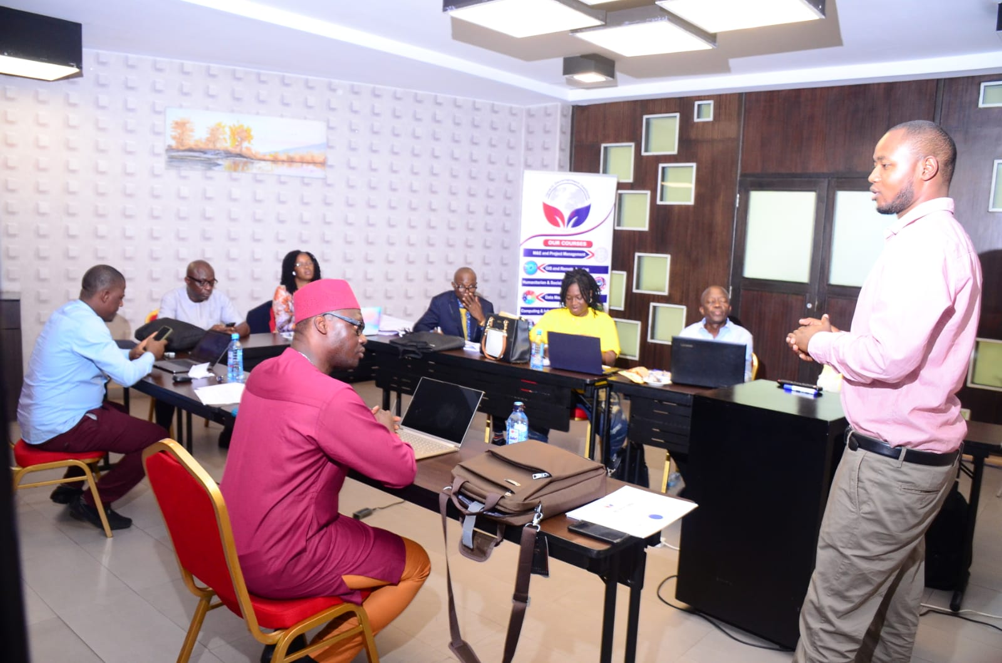

## **DAY 6: MODULE IV: BUSINESS SERVICE AND FINANCE:**

In this session participants were introduced to the role of chain supporters; Business development services (BDS) and Value chain financing, and the role of VCD facilitator in enhancing the availability of BDS to smallholder farmers.Participants were informed about the importance in promoting rural development and guaranteeing food security. It also discussed the importance for reviewing the actors within the agribusiness value chains.

This session included group work where participants were divided into three groups and they were provided with three different case studies on the above topic. After thorough discussion, group presentations were also done and followed by a questions and answers.

## **DAY 7: MODULE IIV: CHAIN CONTEXT: MACRO-ENVIRONMENT:**

Module 7, Macro-Environment, focused on how the macro-environment (ME) of a country affects the development of the Value Chain. It discusses ME as a set of conditions that exist in an economy including the trends in GDP, inflation, employee spending, employment rates, and monetary and fiscal policy; and how its affect decisions on SME spending, borrowing, and investing. The session discussed ME analysis, components and impacts. It further elaborated on the political, economic, social cultural, technological, legal, environmental/physical/natural, and demographic (DEPESTLE) factors that affect VC development.

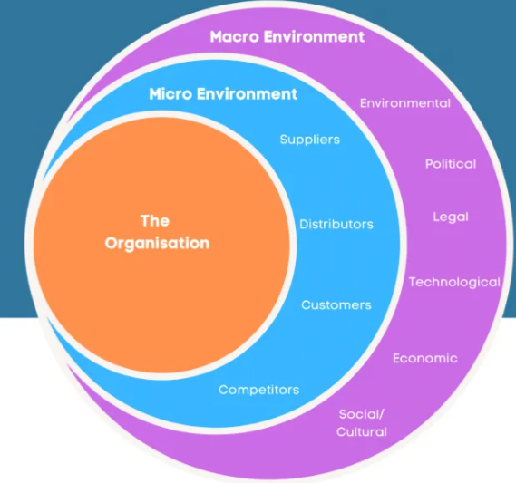

The discussions were laced with practical examples and comparative analysis between Kenya and Sierra Leone. The trainer, Mr. Benjamin Kisiangani provided practical examples of how the macro-environment affects the costs and prices of products sold by SMEs. Participants also analyzed a comparative trend of price increases of local products in Sierra Leone and how that will affect the growth of SMEs.

## **DAY 8: MODULE VIII: DEVELOPING STRATEGIES FOR CHAIN EMPOWERMENT AND BUILDING ENGAGEMENT AND CHAIN DEVELOPMENT:**

In this session participants were introduced to the core concepts of strategies of chain empowerment. The presentations and discussions revolved around the followings:

* Introducing chain empowerment strategies
* Chain or inter-chain upgrading Farmers can also set out on a new value chain: they can start growing a new crop, keep a new species of Livestock, or start a new enterprise such as dairying or agro tourism.
* They may be completely new to these activities, or they may transfer their skills and experience from their existing enterprises.

For development to take place, various actors in the supply chain must invest in a coordinated way.

**Factors that make it difficult for African farmers to benefit from the chains they are involved in**.

* Often involved only in production and not in processing
* Lack an understanding of the market
* Do not control the terms on which they participate in the chain.
* The physical environment may be difficult.
* Poorly served by infrastructure.
* Lack the capital

**WHY EMPOWERMENT**

* Limited access to information
* To create opportunities for the poor,
* 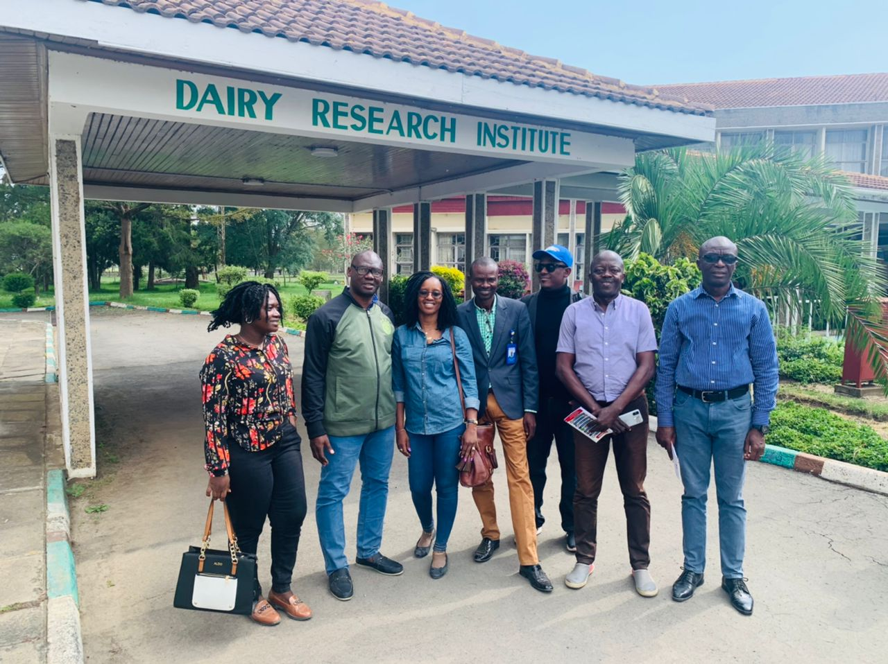To eliminate bottlenecks to their inclusion in dynamic chains.
* To elevate trust among players because

**Group work/ case study on chain empowerment**

All the three groups were also given some questions regarding the case and they were asked to deliver their findings and answers through presentations. Participants successfully delivered the presentations which were followed by a detailed discussion for further clarity of the subject matter. Through this interactive session and group work, it was showcased that participatory approach achieves sustainability and efficacy when people are completely involved in the process.

**Building engagement chain development**

Building engagement: Obtaining “buy-in” from stakeholders.

It was an interactive session presentation that any intervention requires engagement from and between farmers, other actors in the chain and the wider (policy) Environment. The following were discussed as underline approach.

* Identifying common and conflicting issues.
* Identifying chain leaders and facilitators.
* Strengthening linkages and building trust among chain actors.
* Developing a joint chain strategy.
* Learning by doing joint projects and through platform meetings.
* 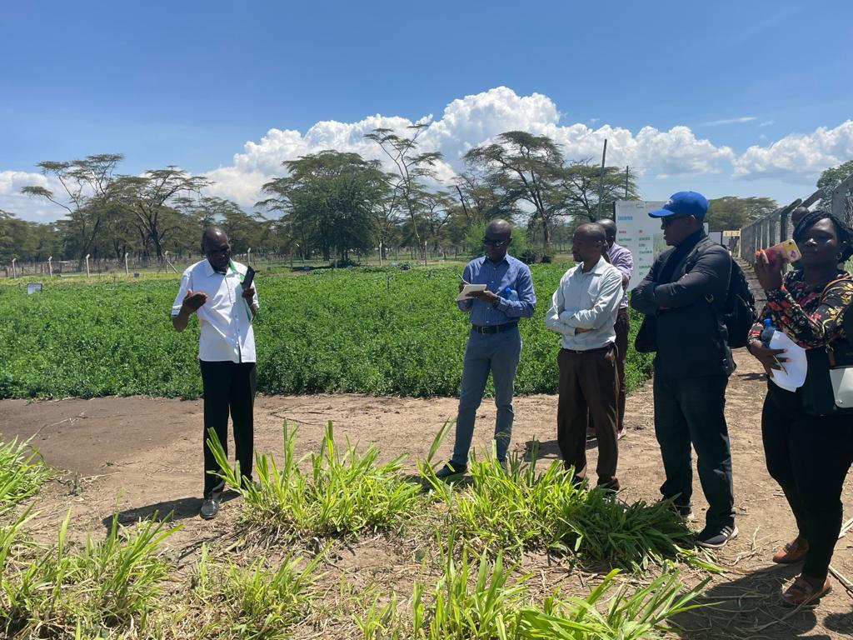Introduction to strategy development

## **DAY 9: MODULE XI: CHAIN MONITORING AND EVALUATION:**

In this session participants were introduced to the core concept of Monitoring and evaluation as one of the phases in the components of chain interventions.



The session however discussed the following topics which includes; **Chain Assessment,** a component that critically analyze situations and set goals, assess farmers, their organization, livelihoods, skills, assets and ambitions. Mapping out the different actors and profile each of them. Analyze the market, trends, prices, comparative advantages, and competitors and review the business environment and analyzing stakeholders and the policy environment.

**Building engagement, a** topic that discussed the Intervention requires engagement from and between farmers, other actors in the chain and the wider (policy) environment, which includes the following elements:

* Identifying common and conflicting issues.
* Identifying chain leaders and facilitators.
* Strengthening linkages and building trust among chain actors.
* Developing a joint chain strategy**.**
* Learning by doing joint projects and through platform meetings.

**Chain development,** a situation where farmers and their organizations may improve their position in the chain in several different ways which includes, **Process upgrading**, **Product upgrading**, **Functional or intra-chain upgrading**, **Chain or inter-chain upgrading.**

**Monitoring and Evaluation,** was also discussed as the impact assessment of value chain interventions.

* To steer the intervention process,
* To design future interventions, and
* To be accountable to donors and farmers (and their organizations).

Monitoring and evaluation are vital for the farmers and their organizations, and for intermediary organizations that assist them. This involves the development of an assessment plan to measure the performance of adaptation efforts in terms of:

* Relevance,
* Effectiveness,
* Efficiency,
* Results and
* Sustainability of the results.

The session further discussed the existing situation within the supply chain, this includes thecost of production, yield, gross margin or profitability, distribution of benefits, improvementsin productsand efficiencies (through process, product, functional or chain upgrading)?

Further to that, market situation was also highlighted.

• **Market penetration:** What percentage of the market do the farmers serve?

• **Sales volume:** How much produce do they sell?

• **Sales value:** How much money does it bring in?

• **Product differentiation:** What range of products do they supply?

Moreover, the issues of livelihoods also formed part of the discussion.

* To judge the effects of the chain on livelihoods, check the effects on different groups in the community: men and women, different ethnic groups, and poor vs better-off people.
* **Role of income from chain** How big a role does income from the chain play in the farmers’ overall livelihoods? What do they use the extra money for?
* **Diversification of income sources** Does the chain add to the farmers’ income sources, or are they over-reliant on a single source?
* **Income stability** Does the chain give the farmers income throughout the year?
* **Employment** What has been the impact on employment?
* **Economic participation** Do the farmers participate in the local economy more? E.g., do they buy and sell more in the local market?

However, participants were engaged in group work and were divided into three groups. Each group were assigned a case study of various scenarios with specific questions. The case was collectively discussed and presentations were done by each of the group. Questions and answers also formed part of the session.

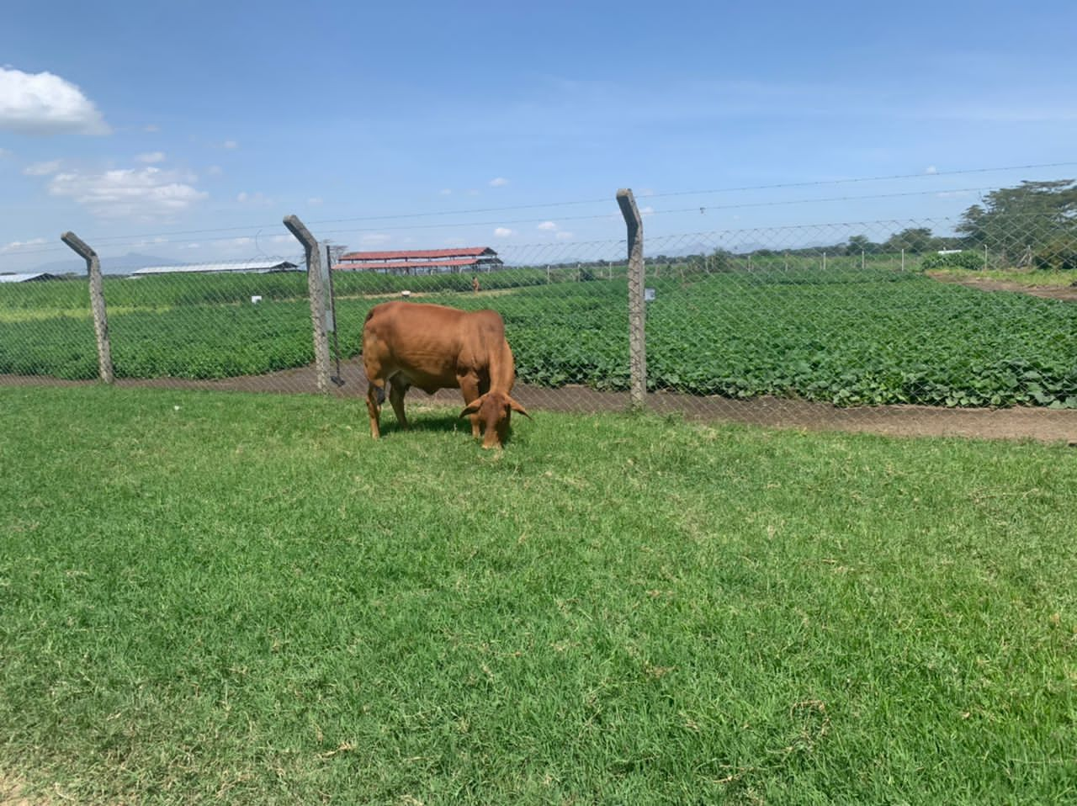

## **DAY 10: MODULE 10: CHAIN LEARNING AND INNOVATION, COMPETENCIES AND ROLES OF CHAIN DEVELOPMENT FACILITATOR’S AND SUPPORT AGENCIES:**

This session focuses on the role of support actors in promoting Value Chain Development. The tutor, Dr. Anna Indeche, excellently facilitated discussions on roles of chain development facilitators, and support agencies, key competencies, technical functionalities, action planning, utilizing the action plan template, and the Do’s and Don’ts of facilitators.

The course discussed in detail the structure of an Action Plan:

* Defining the Value Chain Goals;
* Defining your project objectives;
* Defining action steps;
* Identifying and prioritizing action items;
* Defining roles and responsibilities; allocating resources;
* Setting SMART goals;
* Setting a timeline for Action Plan;
* Writing an Action Plan

1. **EXPECTED IMPACT OF TRAINING TO SMEDA AND SMES**

* Increased knowledge of SMEDA staff on Agricultural Value Chain and Market Linkages Development.
* Knowledge and tools gained will be used to provide trainings to SMEs in the agri-business and agro-processing sector
* There is now in house knowledge at SMEDA to be able to map out various value chains in country, this is very important as it will be useful to understand fully where specific products are in the country and the actors engaged in the various stages of developing the value chain. With this readily available information can be provided for various interventions by our partners.
* If all value chains are mapped, SMEDA will have a database of all actors by sector and the part of the country where various activities are carried, this will help reduce cost of undertaking special market systems analysis each time a new project is to be rolled out.
* On the whole SMEDA appreciate the training opportunity provided by the World Bank through the Sierra Leone Agro-Processing Competitiveness Project which has positioned the Agency well to be able to study the operating environment related to value chain development, mapping and analysis which is very critical for agriculture and agribusiness development in country.
* Lastly the training has equipped the agency staff which will eventually improve on our service delivery and efficiency.

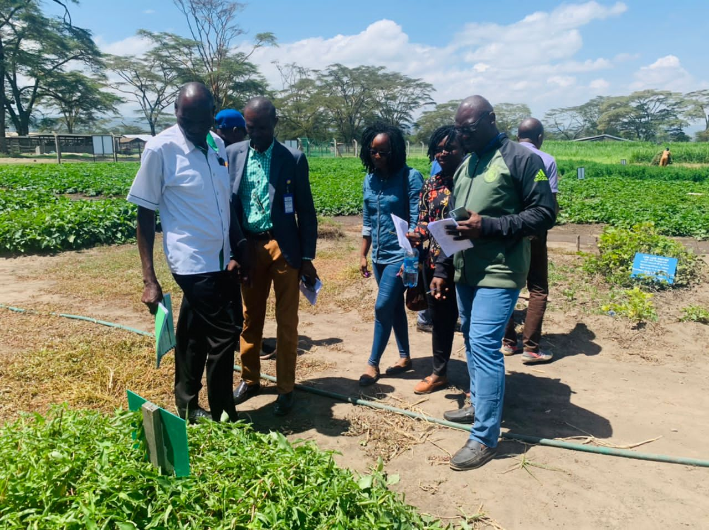

# **PRE AND POST TRAINING ASSESSMENT:**

1. **Pre-Training Assessment of the participants**: Before the commencement of training, participants were asked to briefly explained about their educational background, knowledge and experiences in the training subjects and their contributions in the development of the value chain. Furthermore, participants were also asked to identify their strengths, weaknesses, and area they think need to be improve. In the area of the training modules all 7 participants notes the relevance to the course.
2. **Post-Training Assessment of the Participants:** At the end of the training, participants were issued with a form as a way of collecting data regarding the outcome, training contents and presentations. The form rating scale comprising of four scales (Excellent, Good, Need Improvement and Poor) was used to evaluate the training outcomes and impacts. In their assessment, participants rated the training as very helpful and that the contents and exercises used in the training will helped them to eventually improve in their service delivery and efficiency. Participants also found the training materials to be very useful particularly in the area of cascading the training to others. Presentations were very easy to understand because simple and easy terminologies were used in the material. Other factors such as time division and topics covered during the training were rated between excellent and good. (See Annex II of the post training assessment form)

# **LESSONS LEARNT AND BEST PRACTICES:**

* The visit to the Kenya Agricultural and Livestock Research Organization (KALRO) where we learnt about the Diary Value Chain, Livestock, Animal Feeds and Poultry Value Chain provided an opportunity for us to guide the SMEs engaged in this sector
* In the same vein, participants also learnt about key value chain projects such as Kenya Climate Smart Agricultural Project (KCSAP) and the National Agricultural Rural and Inclusive Growth Project (NARIGP) supported by the Irish Aid, which will serve as an eye opener for the work of the Agency
* We also learnt that in agricultural development, job creation and income generation does not only take place during farming, production, processing or at the selling stages, rather it takes place throughout the entire VC cycle.
* We also that in every Value Chain activity, Mapping and development of a VC questionnaire is necessary
* Establishment of Cooperative Banks and agricultural financing is the way to sustainable SME landscape
* There has been a huge government and donor commitments in terms of support towards the growth and sustainable agri-business and processing SMEs sector.
* There has been feasible commitment, resilience and passion for the development of the SME sector and agri-business and agro-processing in particular, through value chain and value addition approaches.
* 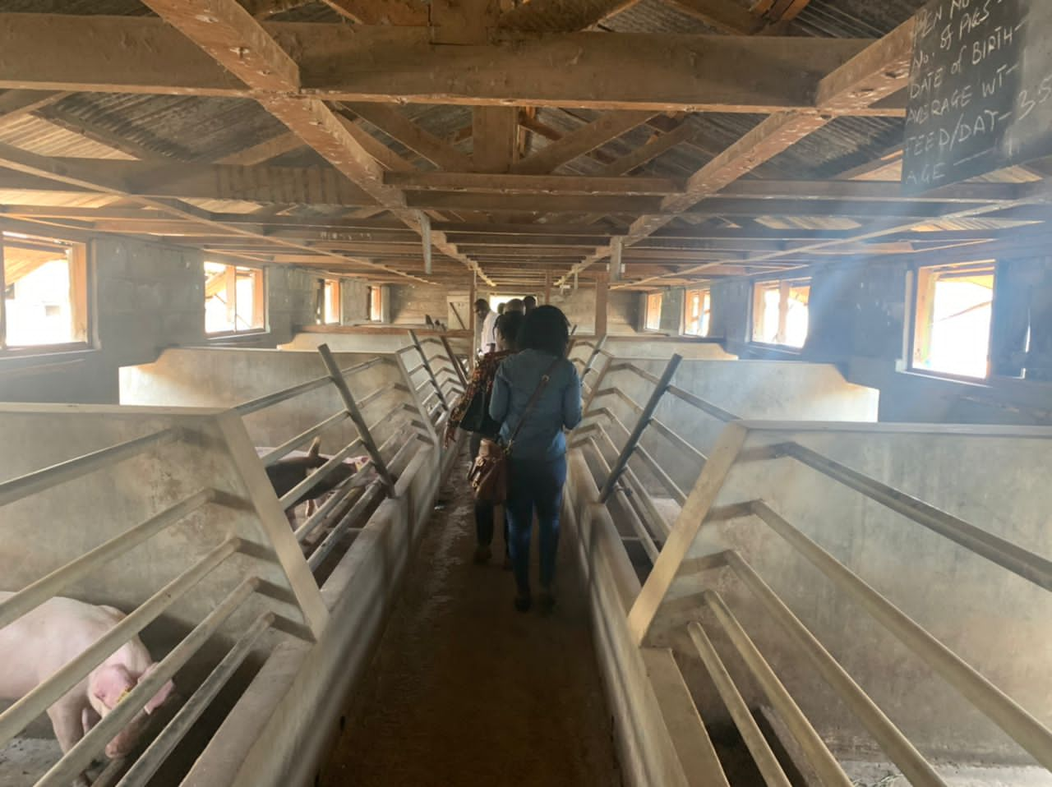The diversity of cultural and gender inclusiveness also viewed as a factor for a successful SME growth in Kenya and by extension in the East African Region.

# **CONCLUSION:**

The closing ceremony of the training was led by Daniel Ndiritu Ndung’u, Training Coordinator, who on behalf of his institution congratulated all 7 staff members on their successful completion of the two weeks training course. He thanked SMEDA and the World Bank Agro-Processing Competitiveness Project for the opportunity given to the Up-Skill Development Institute. He thanked the SMEDA team for their well-behaved manner during their stay in Nairobi Kenya. He thanked the CEO of SMEDA for his exemplary leadership demonstrated during and after classes.

In his closing courtesy, the CEO thanked the Management and resource persons of Up-skill Development Institutes for the quality and resourceful knowledge impacted in the SMEDA team. The training he said, was timely and necessary for the work of SMEDA. He thanked all and sundry for their support over the last two weeks and appreciate the practical nature of the training. The ceremony was climaxed with the distribution of certificates.

# **RECOMMENDATIONS:**

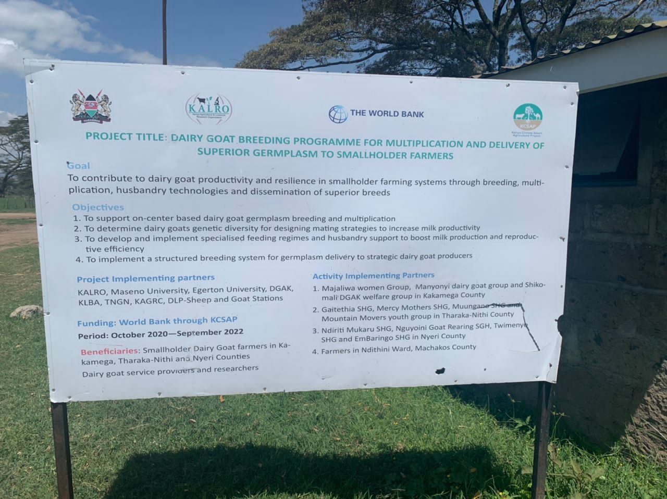SMEDA is still very young and giving the difficult task of developing the SMEs for growth, productivity and competitiveness, there is need for periodic opportunities of this nature of capacity building in various jurisdictions and study visits where best practices from successful SMEs development practices can be learned for replication in Sierra Leone

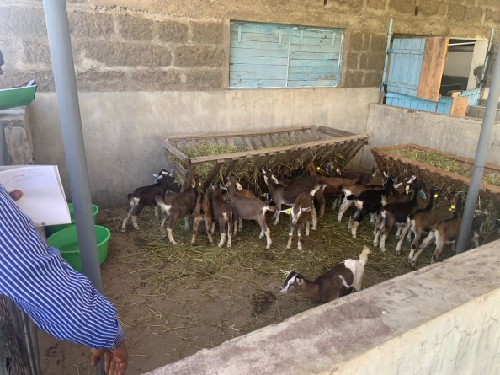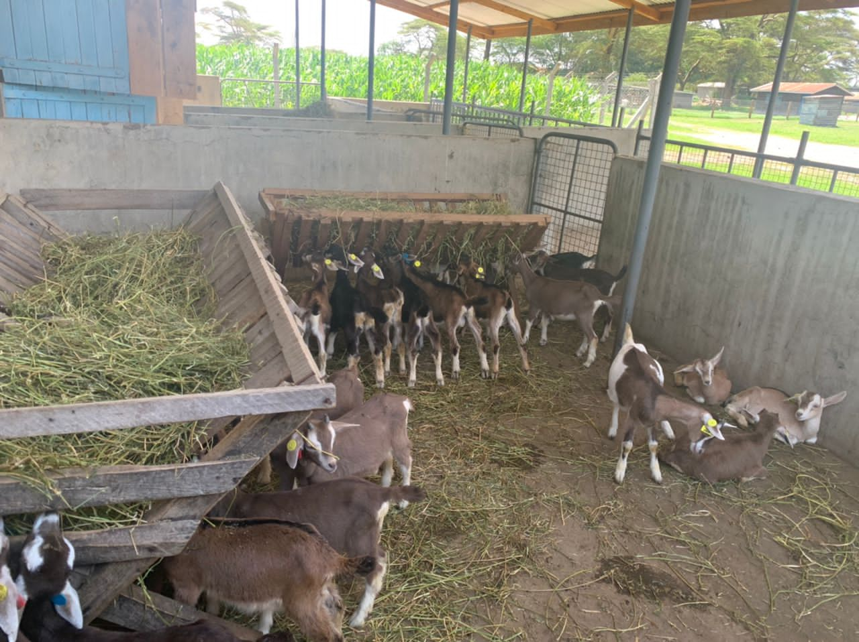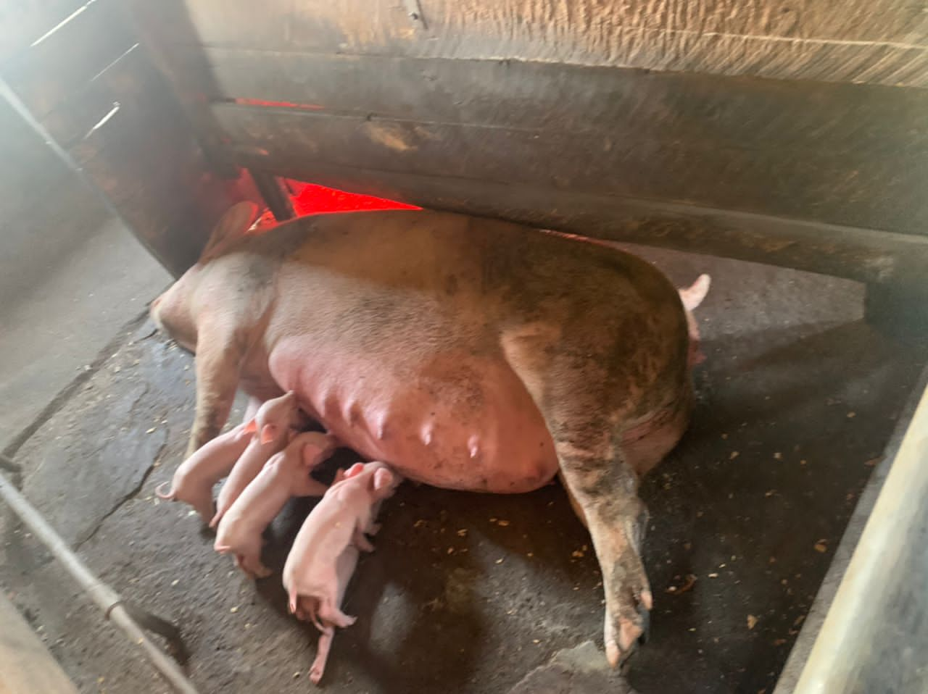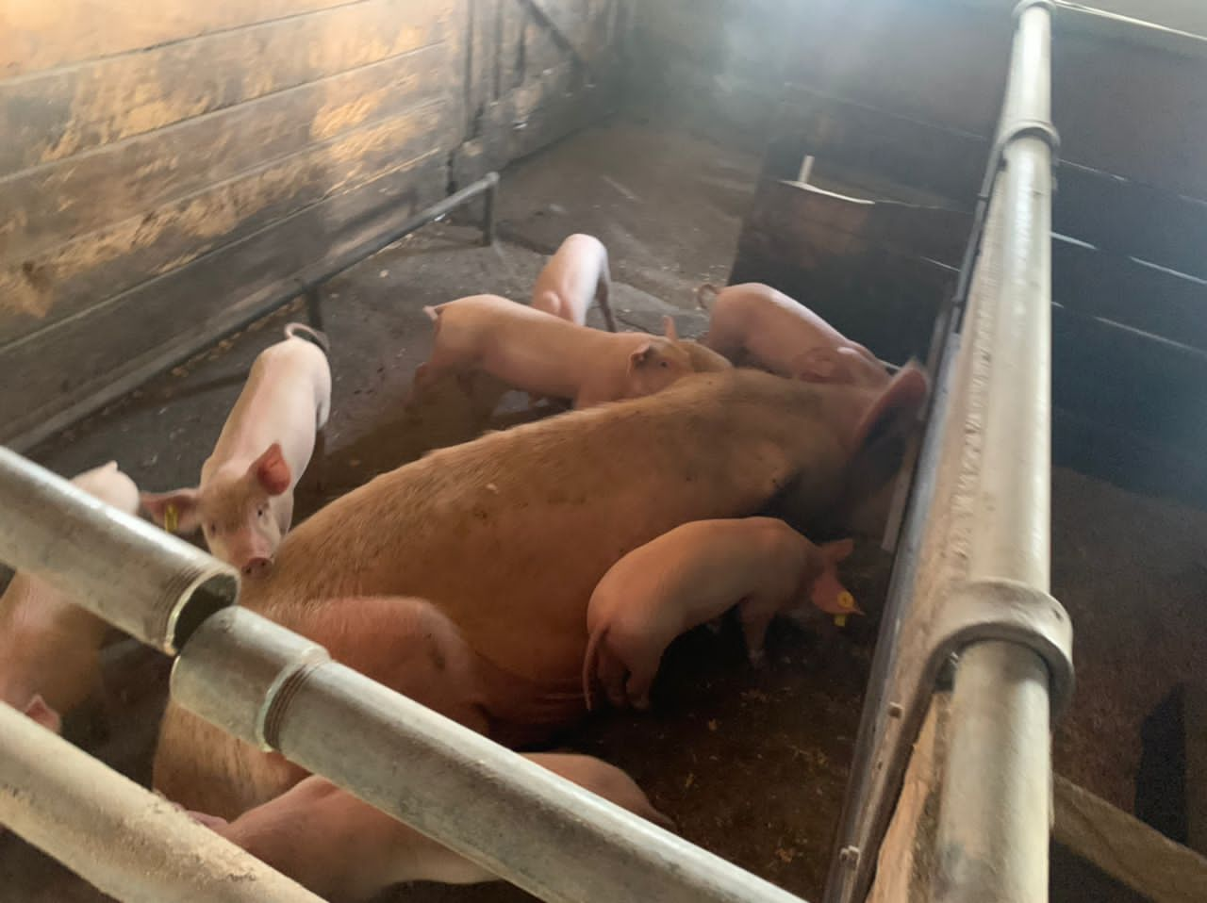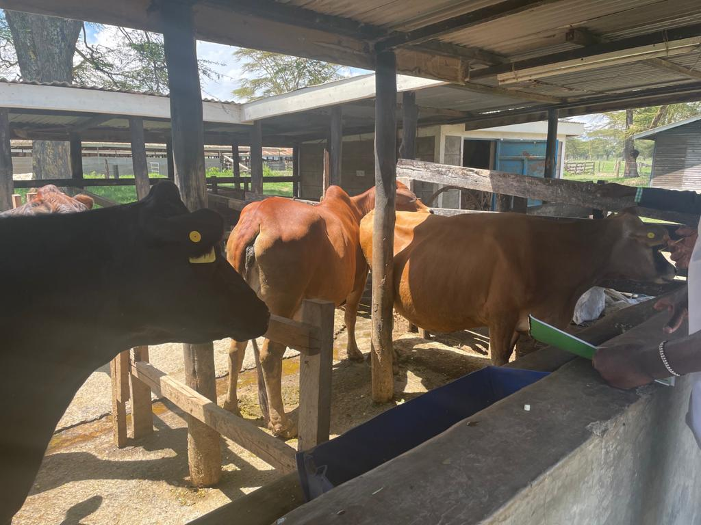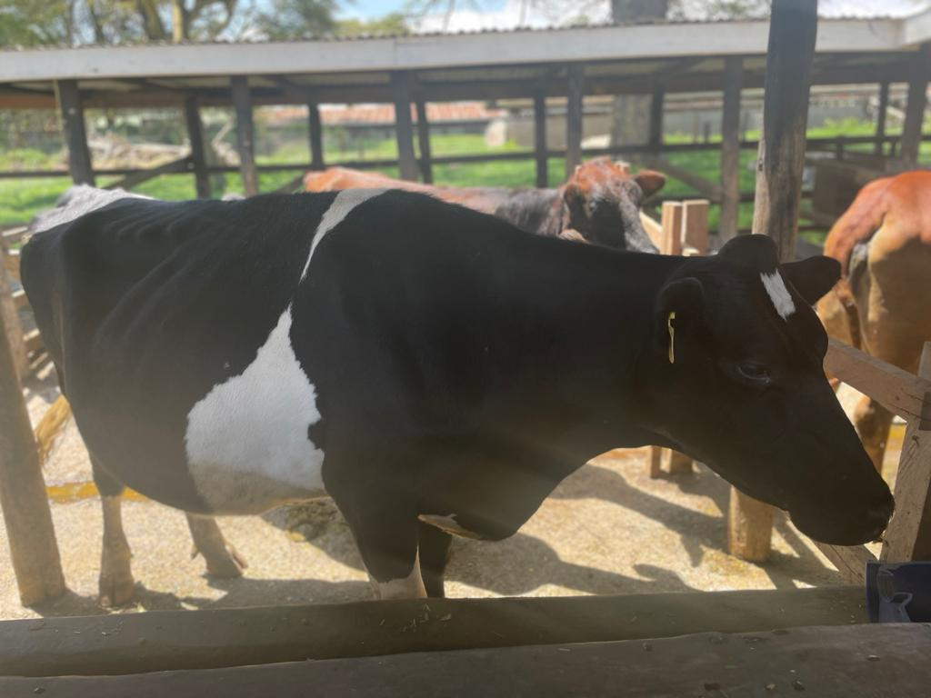

# **ANNEXES I: TRAINNG PROGRAMME**

**Training Agenda on Agricultural Value Chain Development and**

**Market Linkages Course**

**Duration:** 10 days

**Dates:** 16th –27th May 2022Page | **33**

**Training hours:** 09.00 Am – 4.00 Pm

|  |  |  |  |
| --- | --- | --- | --- |
| **Days** | **Time** | **Course Modules** | **Training Materials** |
| **Day 1** | **09.00 am – 04.00 Pm** | **Module 1: Introducing the value chain** | Laptop, PowerPoint, Addition Training Materials, Writing, Pad, Upskill Facilitator |
|  |  | • Formal definition of a value chain |
|  | Tea break – 10.30 Am | • Traditional Selling Systems Compared with a Value Chain Marketing System |
|  |  | • Value Chain Marketing System |
|  | Lunch – 01.00 Pm | • Value Chain Framework |
|  |  | • The “new” framework for Chain Empowerment |
|  | Tea break – 04.30 Pm | • Chain Empowerment |
|  |  | • Case studies and group work |
|  |  |  |  |
| **Day 2** | **09.00 am – 04.00 Pm** | **Module 2: Value chain mapping and analysis** | Laptop, PowerPoint, Addition Training Materials, Writing, Pad, Upskill Facilitator |
|  |  | • Value chain development process |
|  | Tea break – 10.30 Am | • Value chain selection |
|  |  | • Chain mapping and assessment |
|  | Lunch – 01.00 Pm | • Introduction to Value Chain selection process |
|  |  | • Building Engagement and Chain Development/Upgrading |
|  | Tea break – 04.30 Pm | • Chain Monitoring and Evaluation |
|  |  |  |  |
| **Day 3** | **09.00 am – 04.00 Pm** | **Module 3: Analyzing market and market development** | Laptop, PowerPoint, Addition Training Materials, Writing, Pad, Upskill Facilitator |
|  | Tea break – 10.30 Am | • Introduction to market analysis |
|  | Lunch – 01.00 Pm | • Standards and certification |
|  |  | • Analyzing competition |
|  | Tea break – 04.30 Pm | • Group Exercise |
|  |  |  |  |
| **Day 4** | **09.00 am – 04.00 Pm** | **Module 4: Economic Sustainability** | Laptop, PowerPoint, Addition Training Materials, Writing, Pad, Upskill Facilitator |
|  |  | • Analyzing Economic Sustainability of Value Chains |
|  | Tea break – 10.30 Am | • Introduction, calculating costs, revenue, profit margin, value added, value share |
|  | Lunch – 01.00 Pm | • Group work - the economic sustainability of selected value chains |
|  | Tea break – 04.30 Pm |  |
|  |  |  |  |
| **Day 5** | **09.00 am – 04.00 Pm** | **Module 5: Value chain relations and governance** | Laptop, PowerPoint, Addition Training Materials, Writing, Pad, Upskill Facilitator |
|  |  | • Analyzing value chain relations and governance |
|  | Tea break – 10.30 Am | • Intro-Importance of VC relations and governance |
|  | Lunch – 01.00 Pm | • analysis of value chain relations and governance |
|  | Tea break – 04.30 Pm | • Group work, presentation and discussion |
|  |  |  |  |
| **Day 6** | **09.00 am – 04.00 Pm** | **Module 6: Business Services and Finance** | Laptop, PowerPoint, Addition Training Materials, Writing, Pad, Upskill Facilitator |
|  | Tea break – 10.30 Am | • The role of chain supporters; Business development services and Value Chain financing |
|  | Lunch – 01.00 Pm | • Group work – Role of VCD facilitator in enhancing availability of BDS to small holder farmer |
|  | Tea break – 04.30 Pm |  |
|  |  |  |  |
| **Day 7** | **09.00 am – 04.00 Pm** | **Module 7: Chain Context: Macro-environment** | Laptop, PowerPoint, Addition Training Materials, Writing, Pad, Upskill Facilitator |
|  | Tea break – 10.30 Am | • The components of the macro-environment and their impact on value chain development |
|  | Lunch – 01.00 Pm | • Advocacy: - influencing the macro environment; |
|  | Tea break – 04.30 Pm | • Group work – PESTLE analysis of selected value chain |
|  |  |  |  |
| **Day 8** | **09.00 am – 04.00 Pm** | **Module 8: Developing Strategies for Chain Empowerment** | Laptop, PowerPoint, Addition Training Materials, Writing, Pad, Upskill Facilitator |
|  | Tea break – 10.30 Am | • Introducing chain empowerment strategies |
|  | Lunch – 01.00 Pm | • Group work/case study on chain empowerment |
|  | Tea break – 04.30 Pm |  |
|  |  | **Building Engagement and Chain Development** |
|  |  | • Building engagement: obtaining “buy- in” from stakeholders |
|  |  | • Introduction to strategy development |
|  |  |  |  |
| **Day 9** | **09.00 am – 04.00 Pm** | **Module 9: Chain Monitoring and Evaluation** | Laptop, PowerPoint, Addition Training Materials, Writing, Pad, Upskill Facilitator |
|  |  | • Introduction; reiteration of concepts and terminology; |
|  | Tea break – 10.30 Am | • Development of indicators and selection of analytical tools |
|  |  | **Module 10: Chain Learning and Innovation** |
|  | Lunch – 01.00Pm | • Introduction and examples |
|  |  | • Competencies and Roles of chain development facilitators and support agencies |
|  | Tea break – 04.30 Pm | • Roles of chain development facilitator’s, and support agencies |
|  |  | • The dos and don’ts of facilitators; Key competencies of VCD facilitators |
|  |  | • Action planning |
|  |  | • Course evaluation |
|  |  |  |  |
| **Day 10** | **09.00 am – 04.00 Pm** | **Field trip** | Laptop, PowerPoint, Addition Training Materials, Writing, Pad, Upskill Facilitator |
|  |  |  |
|  | Tea break – 10.30 Am |  |
|  |  |  |
|  | Lunch – 01.00 Pm |  |
|  |  |  |
|  | Tea break – 04.30 Pm |  |
|  |  |  |  |

# **ANNEXES II: PARTICIPANTS LIST**

|  |  |  |  |
| --- | --- | --- | --- |
| **No.** | **NAME OF PARTICIPANT** | **DESIGNATION** | **INSTITUTION** |
| 1 | Sharka Samuel Sannoh | Chief Executive Officer | SMEDA |
| 2 | Julius Kandeh-Kanu | Administrative Manager Outreach and Public Education | SMEDA |
| 3 | Melvin H. Foray | Business Development Manager | SMEDA |
| 4 | Augustine Joseph Ellie | Regional Coordinator Southern Region | SMEDA |
| 5 | Kadijah Hammoud | Business Development Officer | SMEDA |
| 6 | Elizabeth Conteh | Business Development Officer | SMEDA |
| 7 | Mohamed Alpha Sheriff | Programme Officer | SMEDA |

# **ANNEXES II: CERTIFICATION PHOTOS**

1. 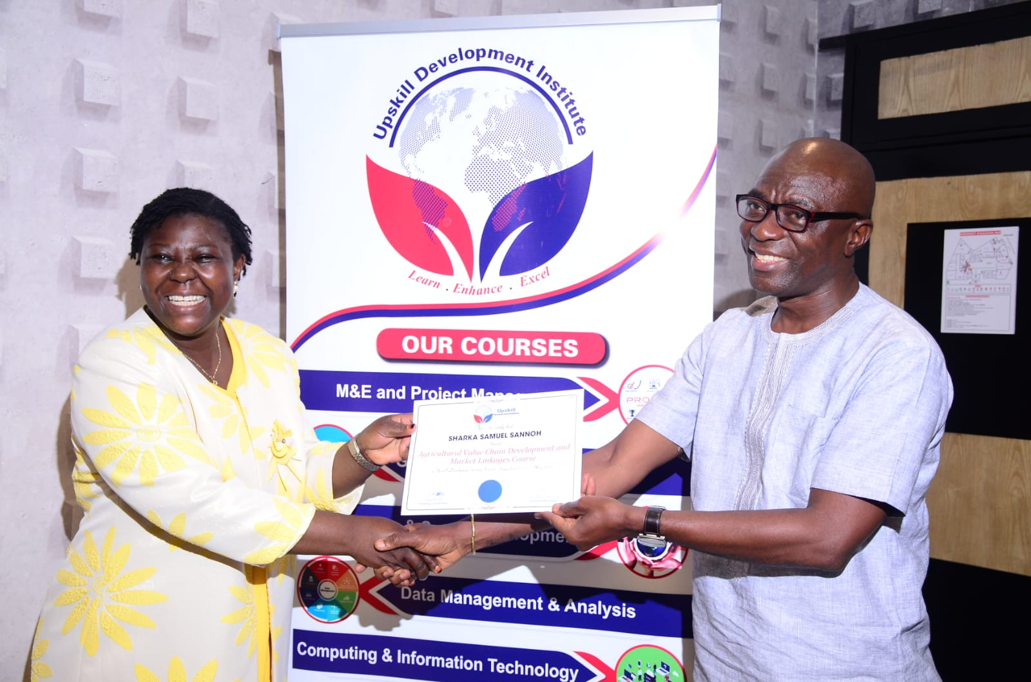**CEO. Sharka Samuel Sannoh, receives certificate from Dr. Annah Indeche**
2. 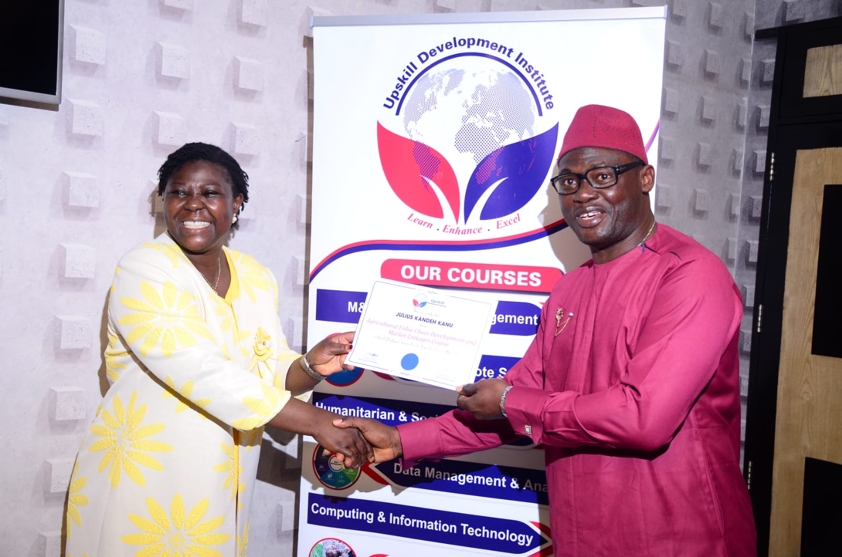**Julius Kandeh-Kanu, receives certificate from Dr. Annah Indeche**
3. 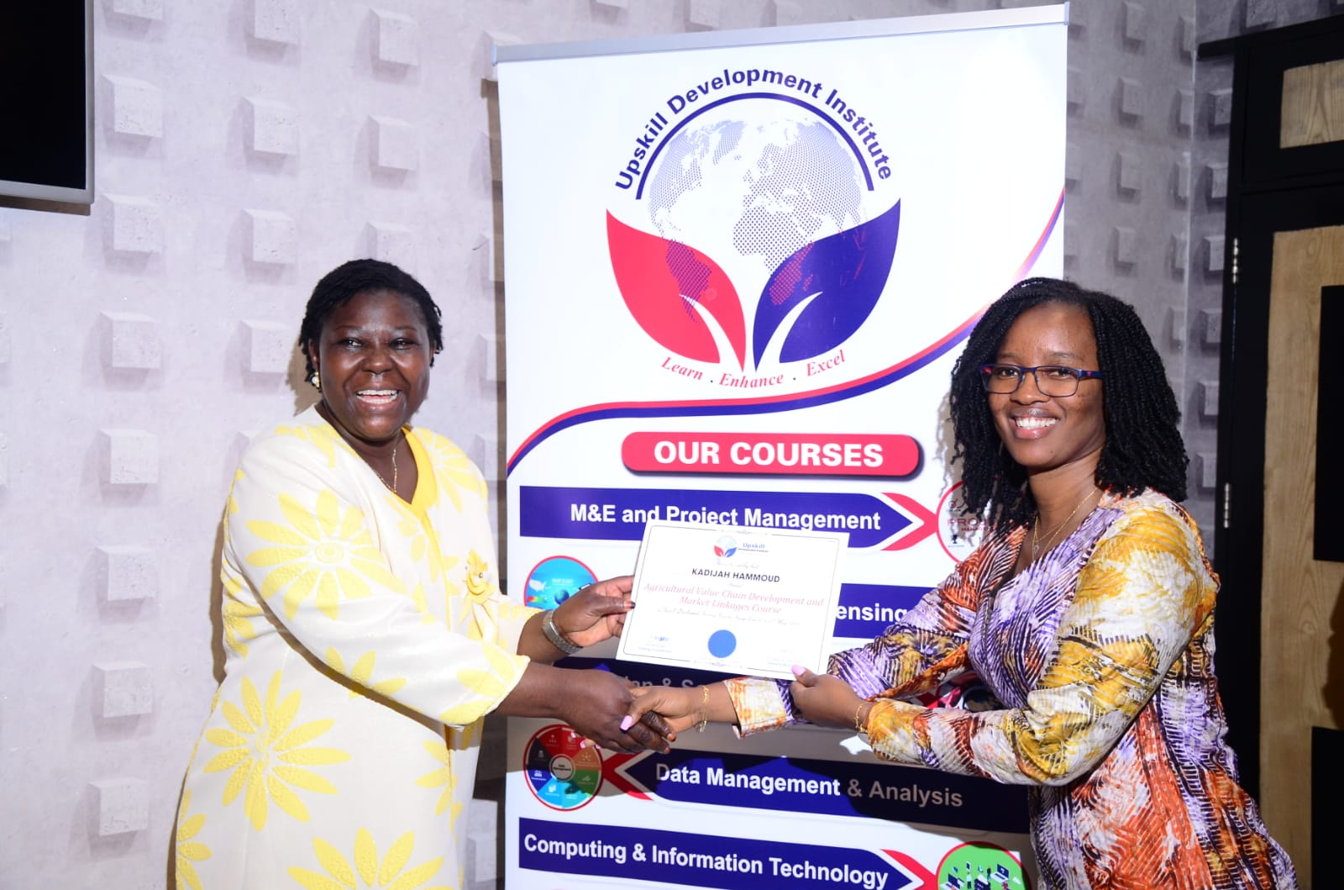 **Kadijah Hammoud, receives certificate from Dr. Annah Indeche**
4. 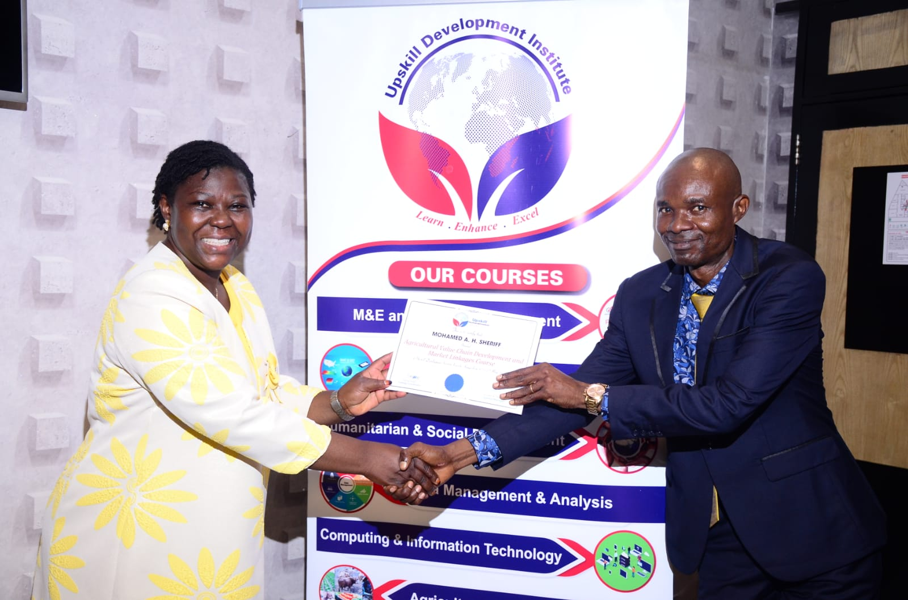 **Mohamed Alpha Sheriff, receives certificate from Dr. Annah Indeche**
5. **Augustine Joseph Ellie, receives certificate from Dr. Annah Indeche**

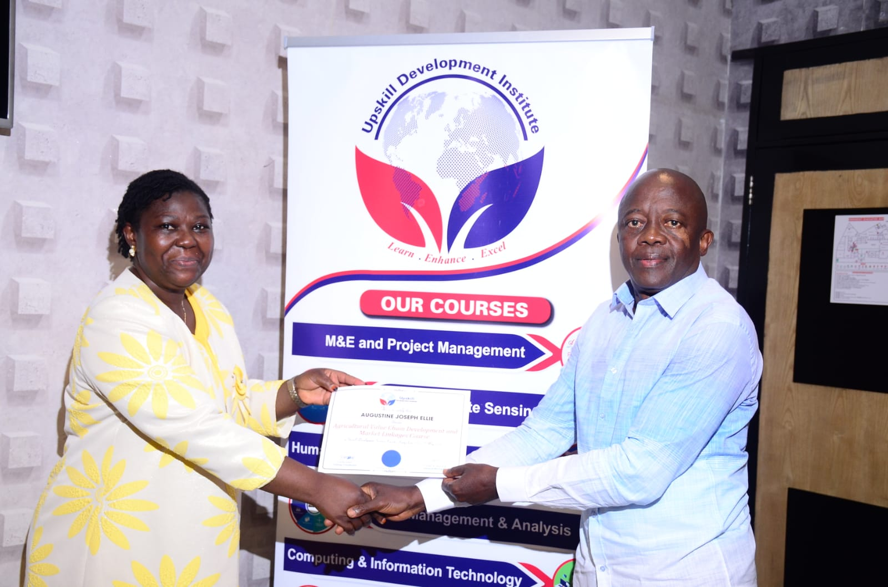

1. 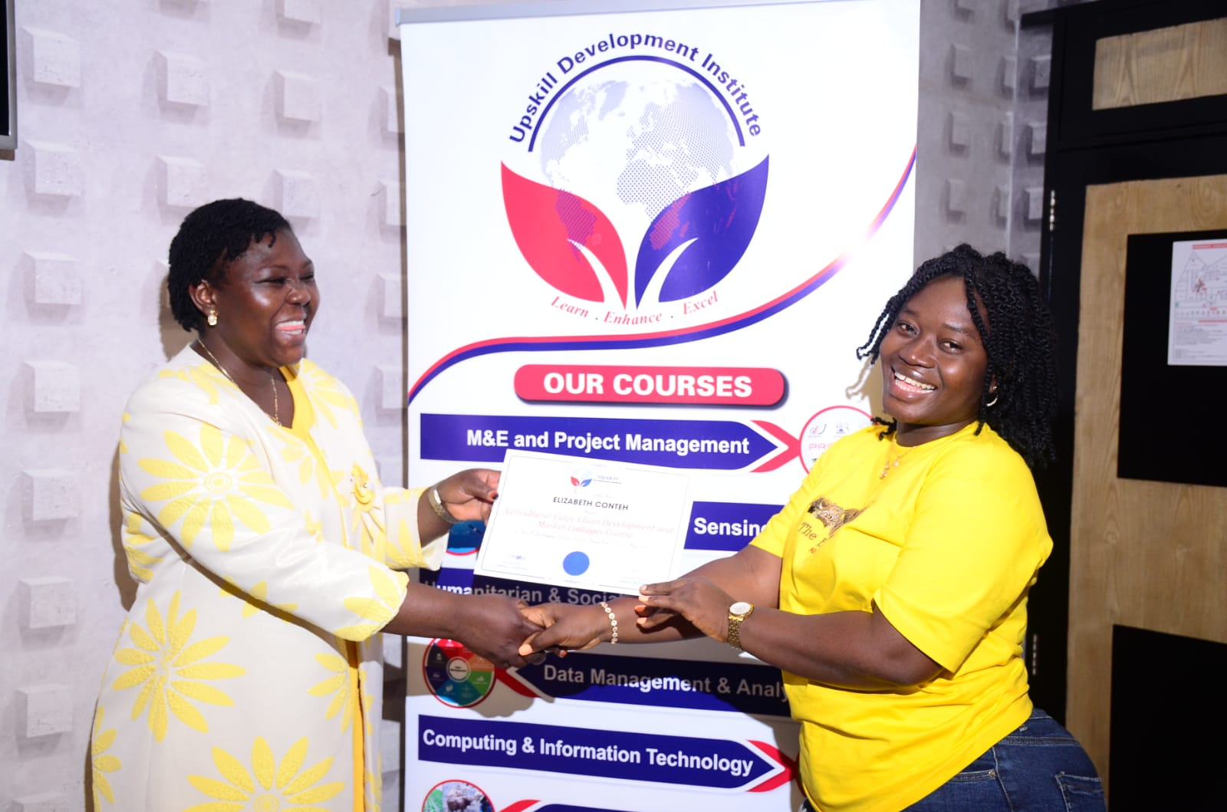**Elizabeth Conteh, receives certificate from Dr. Annah Indeche**
2. 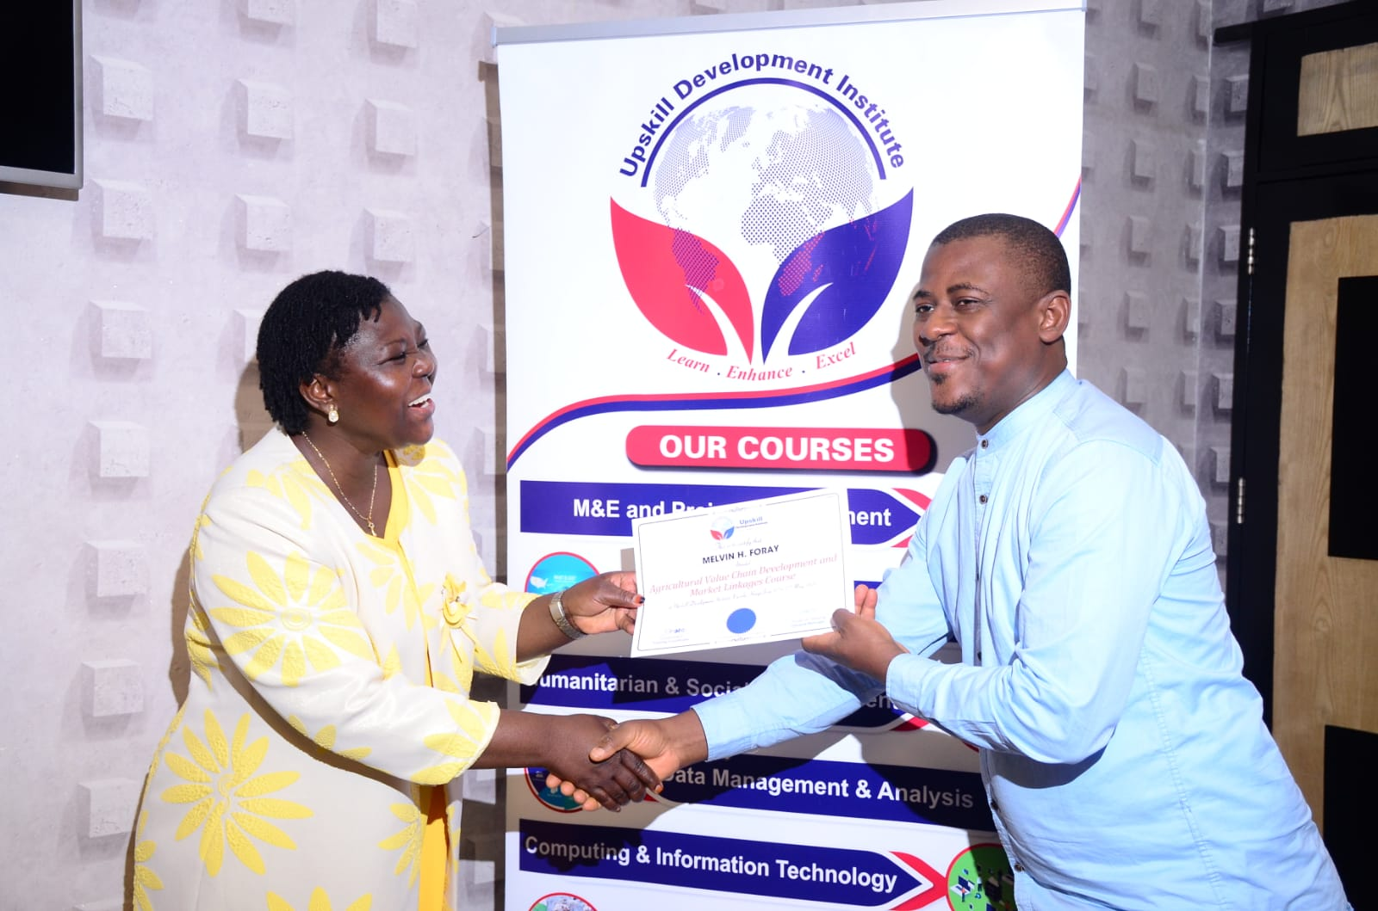**Elizabeth Conteh, receives certificate from Dr. Annah Indeche**
3. 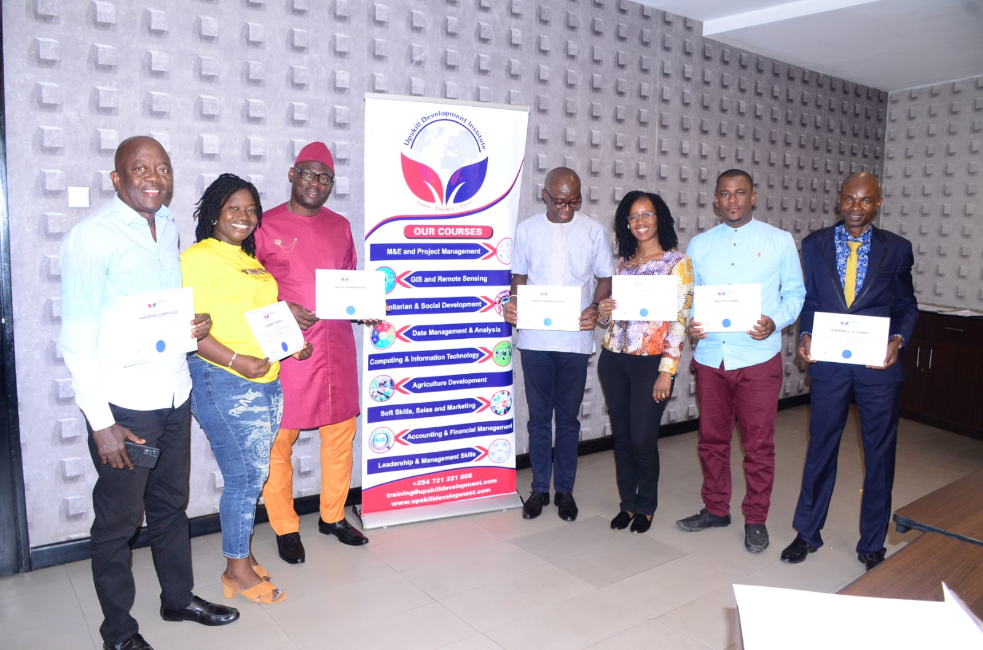**Participants Group Photo**